|  |  |
| --- | --- |
| cetlogo ***CHEMICAL ENGINEERING TRANSACTIONS***  ***VOL. 92, 2022*** | A publication of  aidiclogo_grande |
| The Italian Association  of Chemical Engineering  Online at www.cetjournal.it |
| Guest Editors: Rubens Maciel Filho, Eliseo Ranzi, Leonardo Tognotti  Copyright © 2022, AIDIC Servizi S.r.l.  **ISBN** 978-88-95608-90-7; **ISSN** 2283-9216 | |

Computer-Aided Simulation of Avocado Oil Production in North Colombia

Tamy Herrera-Rodríguez, Vianny Parejo-Palacio, Ángel González-Delgado\*

Nanomaterials and Computer Aided Process Engineering Research Group (NIPAC), Chemical Engineering Department,

Faculty of Engineering, University of Cartagena, Av. del Consulado Calle 30 No. 48-152, Cartagena, Colombia.

agonzalezd1@unicartagena.edu.co

Avocado comprises one of the main economic inputs of the North Colombia region; however, this crop is not taken advantage of properly due to a lack of commercial and production process techniques. Generally, the avocado is trading for human consumption, without transformation, or for the development of new products. Avocado pulp is rich in lipids, which becomes a potential oil source. There are diverse techniques for oil extraction, according to the method used application is defined; supercritical fluids extraction and solvents used in the cosmetic industry, otherwise the food industry employs mechanical and physical methods. In this work, avocado oil extraction using hexane simulated in Aspen plus software; hence, compounds that make up the avocado pulp entered into the software in their proper proportion, including fatty acids, carbohydrates, fiber, ash, protein, and moisture. 10,605 t/y of avocado are processed, which must wash and disinfected, crushed, dried before extraction, and finally, the oil is separated from the solvent by distillation and recirculated to the process, where a detailed process is obtained with flows, the composition of all the streams, and operation conditions as pressure and temperature. The simulation shows a total production of 1,000 t/y of avocado oil, with an extraction yield of 65.19 %. In addition, to validate the design and simulation of the process, the properties of some fatty acids have in avocado oil were compared with data reported in the literature.

* 1. Introduction

The avocado (*Persea Americana mill*.) is one of the most important fruits grown in Colombia. The varieties produced in the country include: Choquette, Santana, Lorena, Semil, Booth-8, Fuerte and Hass (Dávila et al., 2017). This fruit has multiple nutrients such as fatty acids, vitamins, carotenoids, minerals (P, K, Ca, Fe, Na), and essential amino acids (lysine, valine, isoleucine, threonine) (Uchenna et al., 2017). Generally, avocado is consumed fresh or its pulp is processed to obtain spreadable products such as guacamole (Dávila et al., 2017) or used to produce an oil with characteristics similar to those of olive oil (Solarte et al., 2021).

Part of the production of the Montes de María region is not being used in its entirety, due to the presence of pests, lack of implementation of harvesting and marketing strategies, among others (Méndez et al., 2015). For this reason, large amounts of avocado not suitable for consumption are generated, becoming an economic, social, and environmental problem. As an alternative for valorizing this type of biomass, it becomes interesting to obtain value-added products that allow reducing the effects caused by final disposal methods (Poveda et al., 2021). Obtaining products from renewable sources favors the development of agriculture and reduces the deterioration of the environment. In order not to affect food production and consumption, other sources of oil have been sought, such as palm, jatropha (Castillo et al., 2013), avocado crop residues, among others.

Many chemical plants currently in operation were designed under practices that do not make the most of energy and process streams, causing pollution, economic, and social problems. Due to this, it is important to detect and analyze the measures that allow improving existing plants or designing new processes under innovative and sustainable methodologies (Dyudnev et al., 2021). Process simulation is a tool that provides innumerable facilities to the chemical industry because it facilitates the achievement of the proposed objectives, thus saving time and money (Castillo et al., 2013), likewise, the simulation of processes allows analyzing different design configurations and operating conditions, to determine the technical feasibility of a process (Polo, 2017). In the present study, the design and simulation of the process of obtaining avocado oil from the pulp of this fruit were developed, for which the Aspen plus simulator was used. 30 % of the avocado production in the Montes de María region was considered as the processing capacity of the process. In addition, a thermodynamic model was selected that adjusts to the characteristics of the process and equipment necessary to achieve maximum product performance.

* 1. Materials and methods
     1. Process description

Figure 1 shows the oil production chain from avocado pulp, from the harvest of the fruit to the final use of the product.

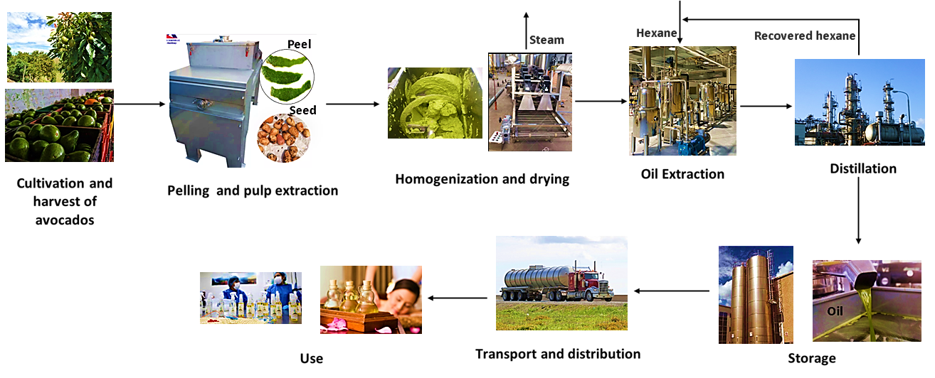

Figure 1: Oil production chain from avocado

Figures 2 and 3 shows the flow diagram of the avocado oil extraction process with the use of organic solvent. 10,605 t/y of avocado of the Creole-Antillean variety (stream 1) are fed to the process, this is washed (W-AVOC) with a solution of sodium hypochlorite, for every 97 kg of avocado 200 liters of water are used (Acosta, 2011).

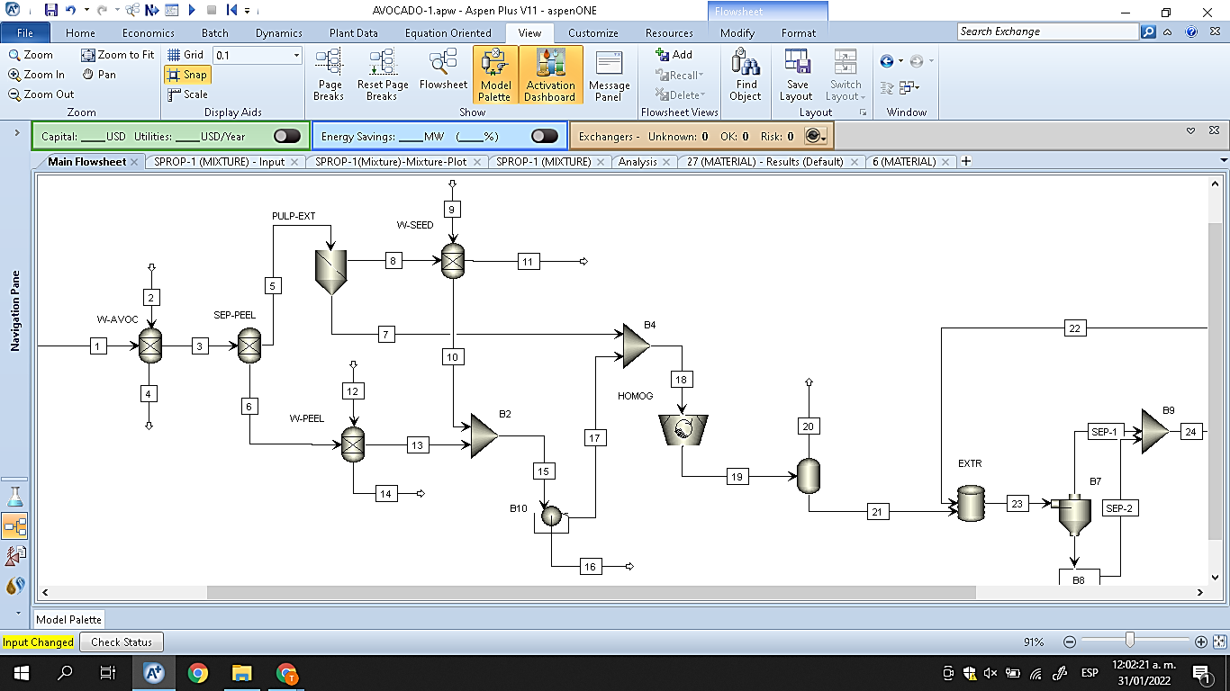

*Figure 2: Main flowsheet of avocado oil extraction process (Part 1).*

Subsequently, the avocado skin is removed (SEP-PEEL), in the next stage (PULP-EXT) the pulp (stream 7) is separated from the seed (stream 8). The shell and the seed are washed to recover the pulp that remains after the peeling and pulping stages, obtaining streams 10 and 13 as recovered pulp and water, respectively, these pass to a centrifugation stage (B10) to remove the water; In total, approximately 26,000 tonnes of water are used per year for the washing stages.

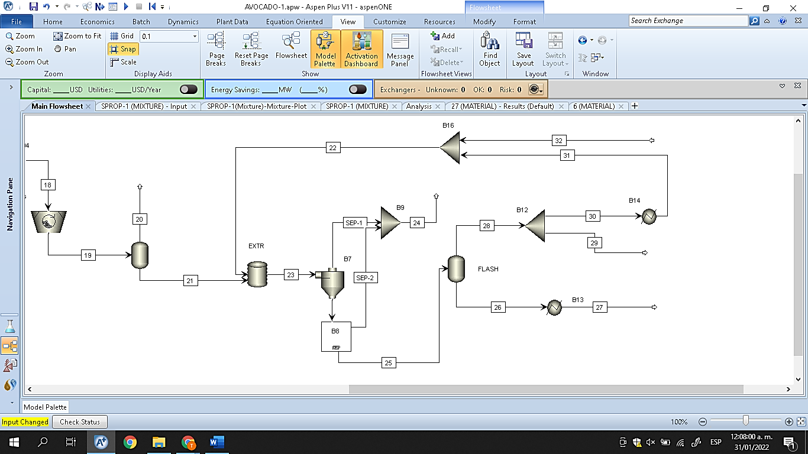

Figure 3: *Main flowsheet of avocado oil extraction process (Part 2)*.

The resulting stream (stream 17) is sent together with the initially extracted pulp (stream 7) to a homogenization stage (HOMOG), then the paste formed (stream 19) is dried at 70 °C to reduce the moisture present in it (Ariza et al., 2011). The dehydrated pulp is put in contact with hexane in the extraction stage (EXTR), this process is carried out at a temperature of 70 °C (Ariza et al., 2011). A mixture of oil, pulp, and the solvent is obtained (stream 23), this is centrifuged (B7) obtaining residual pulp and an oil-solvent mixture (stream 25), which is then sent to a flash distillation (FLASH) to separate the oil from the hexane; 1,000 t/y of avocado oil obtained in stream 27 from the pulp of this fruit. Due to the design of the process, approximately 97 % of the recovered hexane (stream 28) is recirculated to the extraction stage.

* + 1. Process simulation

Table 1: Fatty acid profile of avocado pulp.

|  |  |
| --- | --- |
| **Fatty acid profile** | |
| **Acids** | **mg** |
| Lauric | 1 |
| Myristic | 9 |
| Pentadecanoic | 1 |
| Palmitic | 1,316 |
| Palmitoleic | 438 |
| Heptadecanoic | 2 |
| Stearic | 55 |
| Elaidic | 18 |
| Oleic | 1,648 |
| Linoleic | 920 |
| g-linolenic | 13 |
| Linolenic | 124 |
| Arachidic | 7 |
| Eicosenoic | 5 |
| Behenic | 5 |
| Lignoceric | 10 |
| TOTAL | 4,572 |

Process simulation is a tool that is based on models of physical and chemical processes, unit operations, among others. The phase equilibrium behavior and energy level of the pure compound/mixture system are generally expressed by thermodynamic models (Rezakazemi et al., 2018). Sequential Modular Flowsheet (SMFS) simulator environments such as Aspen Plus are widely used due to their ease of use and robustness in handling large-scale process simulation problems, as they allow working with a large number of operations. Units, process streams, and chemical substances (Nosrati-Ghods et al., 2020). The simulation of the avocado oil production process was carried out with Aspen Plus®, experimental values ​​were taken into account, such as the content of fatty acids in the pulp of this fruit, which was used for the extraction of the oil, the other values ​​are supported in works reported in the literature. The production capacity of the plant was established taking into account the avocado production in the Montes de María region.

From the database of the software, the components or chemical substances that are involved in the process are selected. In addition, the appropriate thermodynamic model and equation of state were selected to estimate the properties of the substances (Meramo et al., 2019). Similarly, it is necessary to supply input conditions such as pressures, temperatures, mass flows, among others. To know the fatty acid profile of avocado from the Montes de María region, the fruit pulp was characterized by gas chromatography with a flame ionization detector (GC/FID), obtaining the results shown in table 1.

* 1. Results and discussion
     1. Simulation

From the processing of 10,605 tons per year of avocado, an avocado oil production of 1,000 t/y is obtained. Table 2 shows the main streams of the process. Below are some of the considerations made in the simulation:

Table 2: Operating conditions and composition of the main streams of the avocado oil extraction process

|  |  |  |  |  |  |  |  |
| --- | --- | --- | --- | --- | --- | --- | --- |
| Streams | 1 | 11 | 21 | 23 | 25 | 27 | 32 |
| T (K) | 298.15 | 298.15 | 343.15 | 326.70 | 326.70 | 298.15 | 298.15 |
| P (bar) | 1 | 1 | 0.31 | 1 | 1 | 1 | 1 |
| m (t/y) | 10,605 | 1,953 | 1,534 | 5,383 | 4,649 | 1,000 | 309 |
| Hexane | 0.00x100 | 0.00x100 | 0.00x100 | 8.35x10-1 | 9.21x10-1 | 2.27x10-2 | 1.00x100 |
| Sodium hyp | 0.00x100 | 0.00x100 | 0.00x100 | 0.00x100 | 0.00x100 | 0.00x100 | 0.00x100 |
| Water | 9.50x10-1 | 8.98x10-1 | 2.10x10-1 | 3.46x10-2 | 4.00x10-6 | 0.00x100 | 0.00x100 |
| Leucine | 3.16x10-3 | 4.98x10-3 | 6.00x10-2 | 9.88x10-3 | 1.00x10-6 | 1.60x10-5 | 0.00x100 |
| Glucose | 2.49x10-2 | 6.46x10-2 | 1.85x10-1 | 3.05x10-2 | 3.00x10-6 | 4.80x10-5 | 0.00x100 |
| Calcium o | 1.15x10-2 | 2.99x10-2 | 8.60x10-2 | 1.42x10-2 | 1.00x10-6 | 2.20x10-5 | 0.00x100 |
| Lauric | 3.00x10-6 | 0.00x100 | 1.30x10-4 | 2.00x10-5 | 2.30x10-5 | 2.90x10-4 | 0.00x100 |
| Myristic | 2.30x10-5 | 0.00x100 | 1.07x10-3 | 1.70x10-4 | 1.86x10-4 | 2.29x10-3 | 0.00x100 |
| Pentadecanoic | 2.00x10-6 | 0.00x100 | 1.10x10-4 | 1.00x10-5 | 1.90x10-5 | 2.40x10-4 | 0.00x100 |
| Palmitic | 4.13x10-3 | 0.00x100 | 1.87x10-1 | 3.08x10-2 | 3.23x10-2 | 3.98x10-1 | 0.00x100 |
| Heptadecanoic | 4.00x10-6 | 0.00x100 | 2.00x10-4 | 3.00x10-5 | 3.50x10-5 | 4.30x10-4 | 0.00x100 |
| Stearic | 1.17x10-4 | 0.00x100 | 5.27x10-3 | 8.60x10-4 | 9.14x10-4 | 1.12x10-2 | 0.00x100 |
| Oleic | 4.16x10-3 | 2.19x10-3 | 1.60x10-1 | 2.64x10-2 | 2.77x10-2 | 3.40x10-1 | 0.00x100 |
| Linoleic | 1.98x10-3 | 0.00x100 | 8.96x10-2 | 1.47x10-2 | 1.55x10-2 | 1.91x10-1 | 0.00x100 |
| Linolenic | 2.97x10-4 | 0.00x100 | 1.34x10-2 | 2.21x10-3 | 2.33x10-3 | 2.86x10-2 | 0.00x100 |
| Arachidic | 5.20x10-5 | 0.00x100 | 2.35x10-3 | 3.80x10-4 | 4.08x10-4 | 5.03x10-3 | 0.00x100 |

Considerations

• The UNIQUAC-RK thermodynamic model was applied, this uses the UNIQUAC activity coefficient model for the liquid phase, which can handle any combination of polar and non-polar compounds, up to a very strong non-ideality; and for the vapor phase the Redlich-Kwong equation of state. The equation of state is used to model single or multiphase systems and measure thermodynamic characteristics such as enthalpy, density, phase balances, etc.; that is why it is important to determine the proper equation of state (Rezakazemi et al., 2018).

• Mixing units were simulated as agitator tanks.

• For homogenization, a ball mill was used.

• 3% of the hexane is recovered.

• 5% of the solids exit in stream 16, the residue stream from the centrifugation stage.

• The final product is left with less than 1% of solvent.

* + 1. Validation of the results

The oil extraction process using hexane as solvent had a yield of 65.19 %, similar to the oil production process reported by Reddy et al. (2012), in which a conversion of 64.76 % of avocado pulp into oil by solvent extraction was achieved. The process was carried out at a temperature of 69.1 °C and atmospheric pressure. An approximation of 99.34 % is obtained taking into account the value reported in the aforementioned study.

Table 3: Validation of results obtained in the simulation for avocado oil

|  |  |  |  |
| --- | --- | --- | --- |
| **Avocado Oil** | **This work** | **Reddy et al. (2012)** | **Accuracy (%)** |
| Yield (%) | 65.19 % | 64.76 % | 99.34 % |
| **Property** | **This work** | **Macías and Rodríguez (2021)** | **Accuracy (%)** |
| Density (g/cm3) | 0.881 | 0.896 | 98.29 % |

Likewise, to validate the results of the simulation, the value of the density of the oil provided by the Aspen plus software was compared with those reported in the literature. As seen in Table 3, the density of the simulated avocado oil is below the value reported by (Macías and Rodríguez, 2021), in which the avocado pulp is heated to extract the oil present in it; the density was evaluated at a temperature of 25 °C. The approximation obtained for this property concerning that of the literature is 98.29 %, showing that the considerations, thermodynamic models, and strategies used in this simulation give good results, since a density similar to that reported in other studies is observed. It should be noted that in many of the consulted investigations other types of properties are reported for this product, such as saponification index, acidity, iodine, among others, but some of them do not appear in the database of the software used or did not show results.

Table 4: validation of properties of fatty acids present in avocado oil

|  |  |  |  |
| --- | --- | --- | --- |
| **Density (g/cm3)** | | | |
| Fatty acids | This work | Cedeño et al. (1999) | Accuracy (%) |
| Palmitic (C16:0) | 0.8526 | 0.8577 | 99.40 % |
| Stearic (C18:0) | 0.8448 | 0.8490 | 99.50 % |
| Oleic (C18:1 n9) | 0.8837 | 0.8904 | 99.24 % |
| **Viscosity (Pa. S)** |  |  |  |
| Fatty acids | This work | Cedeño et al. (1999) | Accuracy (%) |
| Palmitic (C16:0) | 0.00762 | 0.00759 | 99.60 % |
| Stearic (C18:0) | 0.00851 | 0.00830 | 97.46 % |
| Oleic (C18:1 n9) | 0.02964 | 0.02931 | 98.87 % |

Table 4 compares the densities of three fatty acids present in avocado oil. The reference values ​​were taken from the study carried out by Cedeño et al. (1999), in which they report the density of different fatty acids when the temperature varies. The comparison of the palmitic acid obtained in the simulation and that reported in the literature was carried out taking into account a temperature of 65 °C, for the stearic acid the density was compared at a temperature of 75 °C, finally, the density of the acid oleic acid was reported and compared at a temperature of 25 °C. In the case of viscosity for palmitic and stearic acids, it was compared at a temperature of 70 °C and 75 °C, respectively, while for oleic acid at a temperature of 25 °C. Viscosities of some of the acids are reported at temperatures greater than 25 °C, because at lower temperatures they have a viscosity of 0. High precision (>97 %) was obtained when comparing the properties of fatty acids as observed in table 4.

The industrial transformation of avocado generates large amounts of organic waste, mainly composed of seeds and peels with traces of pulp. These wastes are usually composted for use as fertilizer and soil conditioner (Sánchez et al., 2017). As the main raw material, the process uses avocado pulp, and to achieve the extraction of the oil present in it, hexane is used. This process of obtaining avocado oil has been evaluated from the economic point of view, getting a positives investment recovery time, indicating that the assembly of an avocado oil processing plant can be considered economically attractive. In addition to this, other indicators were evaluated to determine the viability of the process. For future research, the use of residues from the process of obtaining avocado oil, such as seed and peel, is recommended to obtain value-added products under the concept of biorefinery.

4. Conclusions

Simulating an industrial production plant allows adjustments to be made that help make the process viable from different points of view since different scenarios and considerations are evaluated from which the one that generates the best economic, environmental and energy results can be chosen. In the present study, an avocado processing plant was simulated to obtain oil, using avocados of the Antillean Creole variety produced in the Montes de María region in northern Colombia. The comparison of properties such as the density and viscosity of some of the fatty acids present in avocado oil allows identifying the validity of the design and simulation of the oil extraction process. Likewise, an oil yield percentage of 65.19 % was obtained, very close to that reported in the literature for a process that uses hexane as solvent. The use of waste streams such as seed and shell is recommended to reduce the accumulation of these wastes in the environment, generating value-added products from these biomasses rich in lignocellulosic material. These are obtained in the peeling and pulping stages of the present process for obtaining avocado oil for cosmetic purposes.

Acknowledgments

Authors thank to University of Cartagena, the Colombian National Planning Department and the Colombian Ministry of Science, Technology and Innovation (MINCIENCIAS) for the supply of equipment and software necessary to conclude successfully this work via Project BPIN Code 2020000100325.

References

Acosta M., 2011, Evaluación y escalamiento del proceso de extracción de aceite de aguacate utilizando tratamiento enzimático, Universidad Nacional de Colombia.

Ariza J., López F., Coyotl J., Ramos M., Diaz J., Martinez A., 2011, Effect of different extraction methods on the fatty acid profile in the avocado (Persea americana Mill. var. Hass) oil, Revista Venezolana de Ciencia y Tecnologia de Alimentos, 2(2), 263–276.

Castillo A., Benigno L., Penedo M., Sanchez A., 2013, Simulation of the Production Process of Biodiesel From Jatropha Curcas Oil, Tecnología Química, 33(2), 107–120.

Cedeño F., Prieto M., Bada J., Suárez R., 1999, Estudio de la densidad y de la viscosidad de algunos ácidos grasos puros, Grasas y Aceites, 50, 359–368.

Dávila J., Rosenberg M., Castro E., Cardona C., 2017, A model biorefinery for avocado (Persea americana mill.) processing, Bioresource Technology, 243, 17–29.

Dyudnev V., Korotkii V., Novgorodtsev S., Boldyryev S., Di Pretoro A., Bragina J., Trusova M., Manenti F., 2021, Energy analysis and process simulation for the energy efficiency improvement of existing chemical plants, Chemical Engineering Transactions, 86(April), 715–720.

Macías D., Rodríguez D., 2021, Sustitución de grasa por aceite de aguacate en la elaboración de salchicha tipo Frankfurt, Ingeniería de Alimentos, 104. https://ciencia.lasalle.edu.co/ing\_alimentos/725

Méndez M., Humanez U., Pérez J., Bertel C., 2015, Distribution strategies Avocado Production Chain in Los Montes de María, Perspectiva Socioeconómica, 1(2), 105.

Meramo S., Moreno K., González A., 2019, Computer-aided simulation and exergy analysis of TiO2 nanoparticles production via green chemistry, PeerJ, 2019(11).

Nosrati N., Naidoo M., Harrison S., Isafiade A., Tai, S., 2020, Embedding aspen custom modeller for bioethanol fermentation into the aspen plus flowsheet simulator, Chemical Engineering Transactions, 80(January), 289–294.

Polo L., 2017, Simulación de una planta de obtención de biodiesel mediante transesterificación catalítica homogénea de trioleína de aceite de palma, Instituto Politécnico Nacional Centro Mexicano para la Producción más Limpia. http://tesis.ipn.mx/handle/123456789/28546

Poveda J., Piedrahita S., Cardona C., 2021, Life Cycle Analysis of Biotechnological Processes based on the Composition of the Raw Material, Eucalyptus, Avocado, and Plantain cases in a Biorefinery System, Chemical Engineering Transactions, 83, 397–402.

Reddy M., Moodley R., Jonnalagadda S., 2012, Fatty acid profile and elemental content of avocado (Persea americana Mill.) oil -effect of extraction methods. Journal of Environmental Science and Health - Part B Pesticides, Food Contaminants, and Agricultural Wastes, 47(6), 529–537.

Rezakazemi M., Rahmanian N., Jamil H., Shirazian S., 2018, Process simulation and evaluation of ethane recovery process using aspen-HYSYS, Chemical Engineering Transactions, 70, 961–966.

Sánchez F., Araus K., Domínguez M., Miguel G., 2017, Thermochemical Transformation of Residual Avocado Seeds: Torrefaction and Carbonization, Waste and Biomass Valorization, 8(7), 2495–2510.

Solarte J., Ortiz M., Restrepo D., Alexander P., Peroza P., Ariel C., Alzate C., 2021, Bioresource Technology Influence of products portfolio and process contextualization on the economic performance of small- and large-scale avocado biorefineries. Bioresource Technology, 342(July).

Uchenna E., Shori A., Baba A., 2017, Inclusion of avocado ( Persea americana ) seeds in the diet to improve carbohydrate and lipid metabolism in rats, Revista Argentina de Endocrinología y Metabolismo, 54(3), 140–148.